

## VISVESVARAYA TECHNOLOGICAL UNIVERSITY

**“JNANA SANGAMA” BELAGAVI-590018, KARNATAKA**

**An Internship Report On**

**“Online Game Store”**

Submitted in Partial the fulfilment of the Requirement for the award of the Degree of

### BACHELOR OF ENGINEERING

**in**

### COMPUTER SCIENCE & ENGINEERING

Submitted by

**S.VenkatGirish [1RL20CS089]**

Of

#### VIII Semester Under the guidance of

**Mr.Anand Reddy G M**(Internal) **Ms.Keerthana**(External) Associate Professor Sr. Manager- IT Department

Dept of CS&E, RLJIT Hindustan Aeronautics Limited

DEPARTMENT OF COMPUTER SCIENCE & ENGINEERING

### R. L. JALAPPA INSTITUTE OF TECHNOLOGY

(Affiliated to Visvesvaraya Technological University, Belagavi |Approved by AICTE, New Delhi)

**NAAC "A" GRADE**

### DODDABALLAPUR-561203 (KARNATAKA) 2023-24



**(A Unit of Sri Devaraj Urs Educational Trust (Regd.))**

## R L JALAPPA INSTITUTE OF TECHNOLOGY

**(Approved by AICTE, New Delhi & Affiliated to VTU, Belagavi) Kodigehalli, Doddaballapur- 561 203**

**Department of Computer Science & Engineering**

## CERTIFICATE

This is to Certify that the internship work entitled **“Online Game Store”** is carried out at “**TechCiti**” by S.**VenkatGirish(1RL20CS089),** a bonafide student of **R. L.Jalappa Institute of Technology**, in partial fulfilment for the award of Bachelor of Engineering in Computer Science & Engineering of **VISVESVARAYA TECHNOLOGICAL UNIVERSITY**, Belagavi during the year 2023-24. It is certified that all corrections/suggestions indicated for internal assessment have been incorporated in the report deposited in the department library. The Internship report has been approved as it satisfies the academic requirements in respect of Internship work prescribed for said degree.

|  |  |  |
| --- | --- | --- |
| **Signature of Guide** | **Signature of HOD** | **Signature of Principal** |
| **Mr.Anand Reddy G M** | **Dr. VIJAYA KARTHIK** | **Dr. VIJAYA KARTHIK** |
| Associate Professor  Dept. of CS&E, RLJIT | Dept. of CS&E  RLJIT | RLJIT |

**Evaluators**

**Name Signature with Date**

**1. _ _ _ _ _ _ _ _ _ _ _ _ _ _ _ _ _**

**2. _ _ _ _ _ _ _ _ _ _ _ _ _ _ _ _ _**

**ABSTRACT**

This internship report has been written at the successful completion of internship training TechCiti Software Consulting Private Limited in IT Department, as a requirement of my BE program in the Department of Computer Science and Engineering, VTU University. As being completely new to practical, corporate world setting, every hour spent there gave me immense amount of experience all the time. But nevertheless, they were all useful for my career.

This report is divided into four chapters. The first chapter of this study deals with the detailed description about the company and its different domains. The second chapter deals with the detailed description about the IT department in the organization as well different services provided by this department. The third chapter is about the Web application which is used in creating a useful website process. The fourth chapter is about the reflection notes that describes my experience while working on the project assigned to me. The last is about the references that are referred while the tasks are performed.

The internship program has broadened my knowledge base, which was made possible through my participation in the various tasks that were assigned to me and my interaction with my colleagues at the organization. It has been a wonderful experience at TechCiti Software Consulting Private Limited and it will be of much benefit to the organization if it continues to create similar platforms for young people as a way of building their experience in the organization.

**ACKNOWLEDGEMENT**

I would like to express my profound grateful to His Divine Soul **Sri R.L. Jalappa** for providing me an opportunity to complete my academics in this esteemed institution.

I would also like to express my profound thanks to honorable **Ms.Swathi** for her continuous support in providing amenities to carry out this internship in this admired institution.

I express my gratitude to **Dr. P. Vijaya Karthik P**, **Principal**, R.L. Jalappa Institute of Technology, for providing me an excellent facility and academic ambience, which has helped me in satisfactory completion of the Internship.

I extend my sincere thanks to **Dr.Vijaya Karthik P**, **Principal & Head**, Department of Computer Science and Engineering; for providing me a valuable support throughout the period of my internship.

I wish to express our heartfelt gratitude to my guide**, Mr.Anand Reddy G M**, **Associate Professor**, Department of Computer Science and Engineering, for his valuable guidance, suggestions and cheerful encouragement during the entire period of my internship.

I also express honest thanks to my External Supervisor **Ms.Keerthana,** Sr. Manager – IT Department, TechCiti Software Consulting Private Limited, for his valuable guidance and inputs to carry out my internship fruitfully.

I also express honest thanks to my internship mentor **Mr.Anand Reddy G M**, Manager-IT Department, TechCiti Software Consulting Private Limited for her constant support and care.

Finally, I take this opportunity to extend my earnest gratitude and respect to my parents, Teaching & Non-teaching staffs of the department, the library staff and all my friends, who have directly or indirectly supported me during the period of my internship.

**S.VenkatGirish [1RL20CS089]**

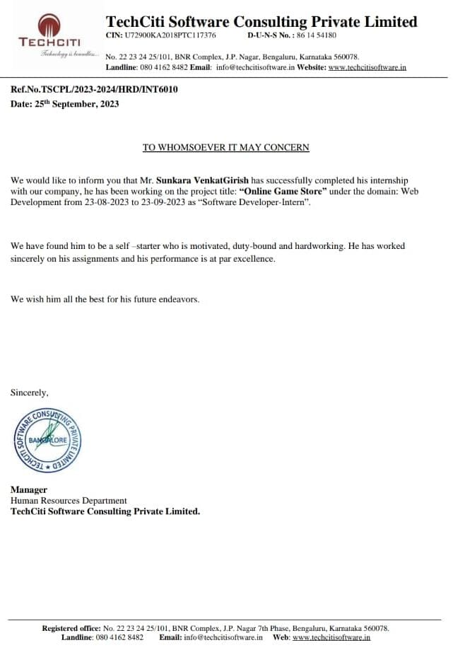

|  |  |  |
| --- | --- | --- |
| Chapter No. | Chapter Name | Page No. |
|  |  |  |
| Chapter 1 | Introduction | 1-3 |
|  | 1.1 Company Profile |  |
|  | 1.2 About Company |  |
|  | 1.3 Tech City Today |  |
|  |  |  |
| Chapter 2 | About the Department | 4-6 |
|  | 2.1 Tech City Private Ld |  |
|  | 2.2 Proposed System |  |
|  | 2.3 Problem Statement |  |
|  | 2.4 Existing System |  |
|  |  |  |
| Chapter 3 |  | 7-10 |
|  | 3.1 Aim | 7-8 |
|  | 3.2 Steps used to build website | 9-10 |
|  | 3.3 Future Enhancement | 10 |
|  |  |  |
| Chapter 4 | Requirement Specification | 11 |
|  | 4.1 Software Requirements |  |
|  | 4.2 Hardware Requirements |  |

|  |  |  |
| --- | --- | --- |
|  |  |  |
| Chapter 5 | Implementation | 12-14 |
| Chapter 6 | Snapshots | 15-18 |
| Chapter 7 | Conclusion | 19 |
| Chapter 8 | References | 20 |

## LIST OF FIGURES

|  |  |  |
| --- | --- | --- |
| **Figure No.** | **Figure Name** | **Page No.** |
| 1.1 | Tech City Logo | 1 |
| 6.1 | Home Page | 15 |
| 6.2 | Login Page | 15 |
| 6.3 | DashBoard | 16 |
| 6.4 | Blog | 18 |

**Chapter 1**

# INTRODUCTION

#### Company Profile:

Techciti Software Consulting Private Limited is a dynamic and innovative software consulting firm dedicated to delivering high-quality solutions to clients worldwide. With a focus on cutting-edge technologies and industry best practices, we specialize in providing customized software development, IT consulting, and digital transformation services to help businesses thrive in the ever-evolving digital landscape.

Our team of experienced professionals combines technical expertise with a deep understanding of business needs to deliver solutions that drive efficiency, productivity, and growth. At Techciti, we are committed to exceeding client expectations, fostering long-term partnerships, and delivering measurable results that empower our clients to succeed in today's competitive market. Contact us today to learn how we can help take your business to the next level.

#### About Company:



**Fig 1.1: Company logo TechCiti Software Consulting Private Limited**

Page 1

TechCiti Software Consulting Private Limited is a leading software consulting firm that specializes in providing innovative solutions to businesses across various industries. Established with a vision to leverage technology for business growth, TechCiti has quickly emerged as a trusted partner for companies seeking to enhance their digital capabilities and achieve strategic objectives. With a strong focus on customer satisfaction and technological excellence, TechCiti is committed to delivering superior services that drive tangible results and foster long-term success for its clients.

Clinic Maintainance System include:

Asset Management: Our systems enable healthcare facilities to efficiently track and manage all physical assets, including medical equipment, furniture, and infrastructure. Through centralized asset databases and intuitive user interfaces, staff can easily monitor asset status, schedule maintenance tasks, and track asset lifecycle information.

Preventive Maintenance Scheduling: Techciti's clinic maintenance systems include robust scheduling functionality for preventive maintenance tasks. Facility managers can create maintenance schedules based on manufacturer recommendations, regulatory requirements, and historical data to proactively address equipment maintenance needs and minimize downtime.

Work Order Management: Our systems facilitate the creation, assignment, and tracking of maintenance work orders, streamlining the entire maintenance workflow. Staff can generate work orders for routine maintenance tasks, repairs, and inspections, assign them to appropriate personnel or external service providers, and monitor progress in real-time.

Inventory Management: Techciti's clinic maintenance systems feature integrated inventory management capabilities to track and manage maintenance-related supplies, spare parts, and consumables. Users can maintain optimal inventory levels, generate purchase orders, and track stock movements to ensure timely availability of resources for maintenance activities.

Compliance Monitoring: We understand the importance of regulatory compliance in the healthcare industry. Our clinic maintenance systems include built-in compliance monitoring features to help facilities adhere to relevant regulations and standards, such as those set forth by regulatory bodies like HIPAA and Joint Commission.

Reporting and Analytics: Techciti's systems provide powerful reporting and analytics tools to help

healthcare facilities gain insights into maintenance performance, asset utilization, and resource allocation. Customizable dashboards and reports enable data-driven decision-making and continuous improvement of maintenance operations.

#### TechCiti Today:

They provide customized solutions for businesses of all sizes with a wide range of services. Our free consultation service helps you determine your requirements and we assist with product selection, configuration, and installation. Our focus is on demonstrating our value by helping you choose the right technology, bringing competitive pricing to the table, remaining predictable in our execution, and providing excellent post-sales support. Established in 2013, TechCiti has become a pioneer in end-to-end IT infrastructure solutions, with business functions in 12+ major Indian cities and satisfied corporate customers.

* + - Extensive Product Selection
    - Competitive pricing

Value added services TechCiti authorised resellers can offer a broad range of products from multiple vendors, providing our clients with access to the latest technology and solutions to meet their specific needs.We help our clients save money and maximize their return on investment, with competitive prices.

We provide clients with value-added services, such as installation, configuration, and training, to ensure that you can use the new products and solutions effectively. Help clients get up and running quickly and minimize the risk of downtime or disruptions.

We have a team of experts who can help evaluate your current IT infrastructure, identify gaps and opportunities, and recommend the best products and solutions to meet your needs. Make informed decisions and maximize the value of your investment.

**Chapter 2**

# ABOUT THE DEPARTMENT

#### 2.1 TechCiti Pvt Lt Bangalore

Techciti Software Consulting Private Limited is a dynamic and innovative software consulting firm dedicated to delivering high-quality solutions to clients worldwide. With a focus on cutting-edge technologies and industry best practices, we specialize in providing customized software development, IT consulting, and digital transformation services to help businesses thrive in the ever-evolving digital landscape.

Our team of experienced professionals combines technical expertise with a deep understanding of business needs to deliver solutions that drive efficiency, productivity, and growth. At Techciti, we are committed to exceeding client expectations, fostering long-term partnerships, and delivering measurable results that empower our clients to succeed in today's competitive market. Contact us today to learn how we can help take your business to the next level.

**2.2** **Proposed System :**

The proposed system is designed to provide multiple techniques and optimized working in a simultaneous fashion from a single interface so that the organizations will be having a cost effective way of working and analysis. All that it fundamentals are properly organized and even the customization provisions are provided for better work orientation. In the proposed system all the related perceptions are provided in an inbuilt format so that the considerations can be accessed on a faster mode.

Some of the important points of the proposed system in as following-

* Collaborative working is supported so multiple analytical teams can associate at one place in terms of the provisional research
* All requirements of the information integration and extraction is associated and even different formats are provided which can be selected and which can be incorporated directly
* The associations that are required for the convertibility will be provided and it will be provided in a selective mood so various options will be provided to the users
* The information that is extracted will be modeled with the help of inbuilt methodology and even direct formulation support is provided
* All related working and acknowledgements will be organized on a central place which will help to maintain the security of the data as suppose multiple research orientations has been undertaken all the related research data will be automatically backed up and saved
* In the proposed system all the related representation methods are provided so that after the Representation the design it can be properly published which includes even the audio
* In the proposed system multiple charting types are provided and even the related templates system is included so the various examples are provided which can be directly incorporated and used
* Media publish provided which can be used for the direct transfer of the related information if required

**2.3** **Problem Statement :**

Various types of problems are associated in the real-time as the differences of understanding is not supported from a single strip chat so the companies are using various types of references based on different types of vendors which makes the work very much complicated. Different types of resources are being utilized by different types of organizations to undertake the related offences of data gathering and other conceptual visualizations

**2.4 Existing System:**

The systematic working is not supported in the existing system and all terms of behavioral understanding and other perception will be quite complicated to get through on a synchronized way. In the existing system we also found that the related collaborated working is not supported and various types of team’s integration and associations on individual perception will be organized making it too lengthy. Some of the points of the existing system are listed below-

* Central coordinated different research consideration is not supported
* The establishment of resource integration is quite complicated as for the perception exploration we require the extraction of data
* The related combination multiple integrated sources is not provided which will have a negative impact on the overall planning and research
* The systematic inclusion of the related changes that has to be oriented is not provided as in terms of the exploration multiple scenarios and behaviors are required to be analyses
* Large data set analysis will be complicated as the conversion system has to be done manually and where multiple required methodological implementations is needed
* Charting conversions according to the choices is not provided
* The sharing options that are needed for the reference to working and for the considerable transfer is also not supported
* Media support is not provided for the direct integration and sharing
* Central collaborated working with all references and data management with all needed security is not provided
* The limitations in terms of the real-time working is also there as the teams are incorporated on various environment and the related perceptions analysis that is required is quite difficult

**Chapter 3**

### 3.1 AIM :

The aim of this project is to design and develop the official website for clinic maintenance system is to effectively manage and streamline maintenance activities within a facility to ensure the smooth operation of medical equipment, facilities, and infrastructure. The primary objectives of such a system typically include:

Equipment Reliability: Ensuring the reliability and availability of medical equipment by implementing preventive maintenance schedules, conducting routine inspections, and promptly addressing equipment breakdowns or malfunctions.

Cost Reduction: Minimizing maintenance costs by optimizing resource allocation, scheduling maintenance activities efficiently, and proactively identifying and addressing potential issues before they escalate into costly repairs.

Enhancing patient safety by maintaining medical equipment in optimal working condition, adhering to regulatory standards and guidelines, and reducing the risk of equipment failure during patient care procedures.

#### 

#### What is a website?

A website is a collection of web pages and related digital content that are typically identified by a common domain name and can be accessed via a web browser on the internet. Websites are designed to provide information, resources, or services to users.

**Some key components and characteristics of a website:**

1. Web Pages: Websites consist of individual web pages, each containing text, images, multimedia, and hyperlinks. Web pages are written in HTML (Hypertext Markup Language), which defines the structure and content of the page.
2. Domain Name: A domain name is the human-readable address used to access a website. It typically consists of a unique name (e.g., "example") and a top-level domain (e.g., ".com"). For example, "[www.example.com](http://www.example.com/)" is a domain name.
3. Web Server: Websites are hosted on web servers, which are specialized computers that store and serve the website's files and content to users when they request it through their web browsers.
4. Navigation Menu: Websites often have a navigation menu or toolbar that helps users move between different pages and sections of the site. This makes it easy to explore the content.
5. Content: Websites can contain a wide variety of content, including text articles, images, videos, audio, downloadable files, forms, and interactive elements. The content is organized and presented in a user- friendly manner.
6. Hyperlinks: Hyperlinks (or links) are interactive elements that allow users to navigate between web pages or access external resources by clicking on them. Links are a fundamental part of web navigation.
7. Design and Layout: The design and layout of a website determine its visual appearance and user interface. A well-designed website is user-friendly, visually appealing, and responsive to different devices and screen sizes.
8. Interactivity: Many websites include interactive features such as contact forms, search functionality, e-commerce capabilities, and user accounts. These features enable users to interact with the site and perform various actions.
9. Security: Website owners and developers implement security measures to protect the site and its users from threats such as hacking, malware, and data breaches.
10. Mobile Responsiveness: Modern websites are designed to be responsive, meaning they adapt to different screen sizes and devices, including smartphones and tablets. This ensures a consistent user experience across platforms.
11. Content Management System (CMS): Some websites are built using content management systems like WordPress, Drupal, or Joomla. These systems make it easier for users to create, edit, and manage website content.

#### 3.2 Steps Used to Build our website

Creating a website using Frontend tools involves several steps, from planning and designing to development and

testing.

1. Planning and Conceptualization:
   * Determine the purpose of our website.
   * Identify our target audience.
   * Creating a sitemap or wireframe to visualize the website's structure.
2. Design:
   * Choosing a color scheme and typography that align with our theme.
   * Creating a layout for our website, including the placement of headers, footers, navigation menus, and content sections.
   * Design any logos, images, or graphics you'll use on the site.
3. HTML (Hypertext Markup Language):
   * Start by structuring our website's content using HTML.
   * Used HTML tags to define headings, paragraphs, lists, links, images, and more.
   * Organizing our content into a hierarchy with HTML elements like `<header>`, `<nav>`, `<main>`, and

`<footer>`.

1. CSS (Cascading Style Sheets):
   * Applying styles to our HTML elements using CSS.
   * Defining styles for fonts, colors, margins, padding, and more.
2. Bootstrap:
   * Bootstrap is a front-end framework that provides pre-designed UI components and a responsive grid system.
   * Utilizing Bootstrap's CSS classes for buttons, forms, navigation bars, and more.
3. JavaScript:
   * Add interactivity and dynamic behavior to your website using JavaScript.
   * Use JavaScript to validate forms, create image sliders, implement navigation menus, and more.
   * Consider using JavaScript libraries or frameworks like jQuery or React for complex functionality.
   * Optimize JavaScript code for performance and ensure it's error-free.
4. Testing:
   * Testing our website on different browsers (e.g., Chrome, Firefox, Safari, Edge) to ensure compatibility.
   * Verifying that our site is responsive and displays well on various devices (desktop, tablet, mobile).
   * Check for broken links, typos, and other issues.
   * Testing any interactive features and forms for functionality and user-friendliness
5. Optimization:
   * Optimizing our website's performance by minimizing file sizes (HTML, CSS, JavaScript, and images).
   * Ensure your website is SEO-friendly by using appropriate meta tags and optimizing content for search engines.

#### Future Enhancement

* + - Enhanced Reporting and Analytics: Adding advanced reporting and analytics capabilities to provide insights into maintenance trends, equipment utilization, and cost analysis, facilitating data-driven decision-making.
    - Inventory Management: Expanding the system to include inventory management functionality, enabling automatic replenishment of spare parts and consumables based on usage and demand forecasts.
    - Compliance Management: Incorporating features for regulatory compliance management, including tracking and documenting compliance with industry standards and regulations.

**Chapter 4**

# REQUIREMENT SPECIFICATION

Visual Studio 2019 delivers on Microsoft’s vision of smart client applications by letting developers quickly create connected applications that deliver the highest quality rich user experiences. This new version lets any size organization create more secure, more manageable, and more reliable applications that take advantage of Windows Vista, windows10, 2019 Office System and the Web. By building these new types of applications, organizations will find it easier than ever to capture and analyze information so that they can make effective business decisions.

#### Software Requirements

* + 1. **Development Environment**: Text Editor or IDE (e.g., Visual Studio Code, WebStorm), Web Browsers (Chrome, Firefox, Edge) and Git and Version Control Platform (GitHub).
    2. **Web Technologies:** Front-End Frameworks (e.g., Bootstrap, React), and Back-End Technologies (e.g., PHP, Node.js).
    3. **Database and Servers:** Databases (MySQL, PostgreSQL) and Web Servers (Apache).
    4. A Visual Studio compiler is required for compiling the source code to make the executable file which can then be directly executed.

#### Hardware Requirements

The hardware requirements are very minimal and the software can run on most of the machines.

* Processor - Intel 486/Pentium processor or above.
* Processor Speed - 500 MHz or above
* RAM - 64MB or above Storage Space - 2 MB or above, hard disk -10MB.
* Monitor resolution - A color monitor with a minimum resolution of 1000*700
* Supports both single &double buffering.

Page 11

**Chapter 5**

# IMPLEMENTATION

<!doctype html>

<html lang="en">

<head>

<meta charset="utf-8">

<meta name="viewport" content="width=device-width, initial-scale=1, shrink-to-fit=no">

<meta name="description" content="">

<meta name="author" content="MartDevelopers">

<meta name="generator" content="Jekyll v3.8.5">

<link rel="shortcut icon" href="Admin/assets/img/logo-fav.png">

<title>Orion Healthcare Hospital Management System </title>

<!-- Bootstrap core CSS -->

<link href="assets/css/bootstrap.min.css" rel="stylesheet">

<style>

.bd-placeholder-img {

font-size: 1.125rem;

text-anchor: middle;

-webkit-user-select: none;

-moz-user-select: none;

-ms-user-select: none;

user-select: none;

}

@media (min-width: 768px) {

.bd-placeholder-img-lg {

font-size: 3.5rem;

}

}

</style>

<!-- Custom styles for this template -->

<link href="assets/css/pricing.css" rel="stylesheet">

</head>

<body>

<div class="d-flex flex-column flex-md-row align-items-center p-3 px-md-4 mb-3 bg-white border-bottom shadow-sm">

<h5 class="my-0 mr-md-auto font-weight-normal">OHCMS</h5>

</div>

<div class="pricing-header px-3 py-3 pt-md-5 pb-md-4 mx-auto text-center">

<h1 class="display-4">OHCMS Modules.</h1>

<p class="lead">Please login to your respective department module.</p>

</div>

<div class="container">

<div class="card-deck mb-3 text-center">

<div class="card mb-4 shadow-sm">

<div class="card-header">

<h4 class="my-0 font-weight-normal">Registration Desk</h4>

</div>

<div class="card-body">

<h1 class="card-title pricing-card-title"></h1>

<a href="RegistrationDesk/employee_login.php" class="btn btn-lg btn-block btn-outline-primary">Login</a>

</div>

</div>

</div>

<div class="card-deck mb-3 text-center">

<div class="card mb-4 shadow-sm">

<div class="card-header">

<h4 class="my-0 font-weight-normal">Laboratory </h4>

</div>

<div class="card-body">

<h1 class="card-title pricing-card-title"></small></h1>

<a href="Laboratory/employee_login.php" type="button" class="btn btn-lg btn-block btn-outline-primary">Login</a>

</div>

</div>

<div class="card mb-4 shadow-sm">

<div class="card-header">

<h4 class="my-0 font-weight-normal">Pharmacy</h4>

</div>

<div class="card-body">

<h1 class="card-title pricing-card-title"></h1>

<a href="Pharmacy/employee_login.php" type="button" class="btn btn-lg btn-block btn-outline-primary">Login</a>

</div>

</div>

<div class="card mb-4 shadow-sm">

<div class="card-header">

<h4 class="my-0 font-weight-normal">Departmental Heads</h4>

</div>

<div class="card-body">

<h1 class="card-title pricing-card-title"></h1>

<a href="DepartmentHead/dept_head_login.php" class="btn btn-lg btn-block btn-outline-primary">Login</a>

</div>

</div>

<div class="card mb-4 shadow-sm">

<div class="card-header">

<h4 class="my-0 font-weight-normal">Administrator </h4>

</div>

<div class="card-body">

<h1 class="card-title pricing-card-title"></h1>

<a href="Admin/ohcms_admin_login.php" class="btn btn-lg btn-block btn-outline-primary">Login</a>

</div>

</div>

</div>

<footer class="pt-4 my-md-5 pt-md-5 border-top">

<div class="row">

<div class="col-12 col-md">

<small class="d-block mb-3 text-muted">&copy; All Rights Reserved Orion Healthcare Hospital Management System 2019-<?php echo date('Y'); ?>. Crafted With Love by <a href="https://martmbithi.github.io" target="_blank">MartDevelopers</a>.</small>

</div>

</footer>

</div>

</body>

</html>

# Chapter 6

**SNAPSHOT**

#### 6.1 Home Page

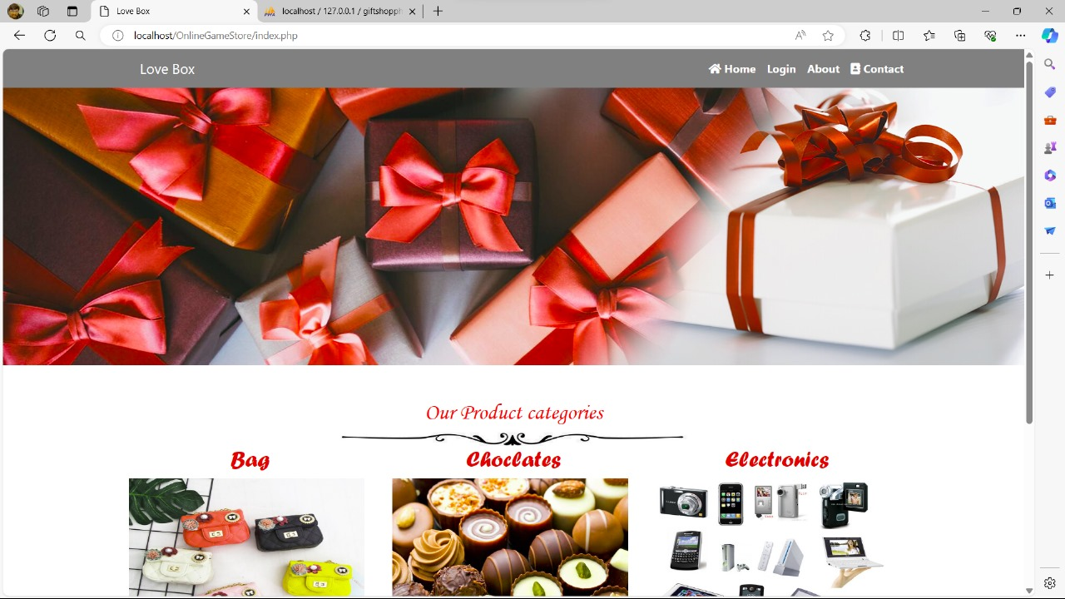

**6.2 Login Page**

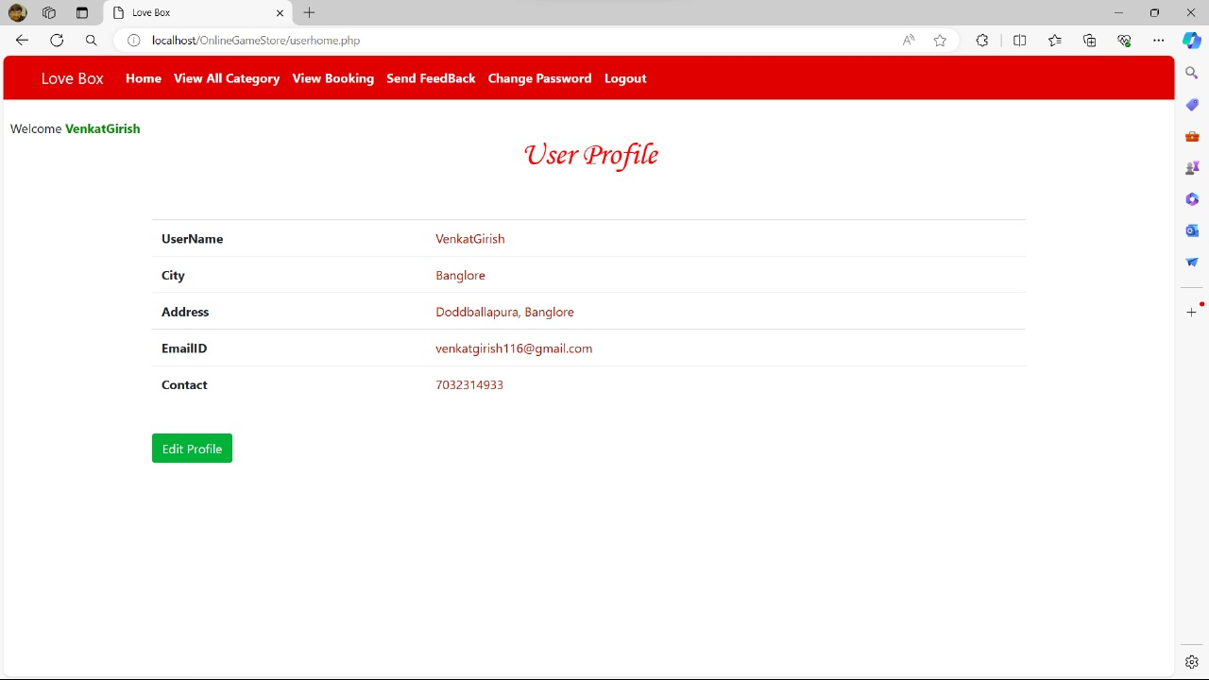

* 1. **DashBoard & Search**

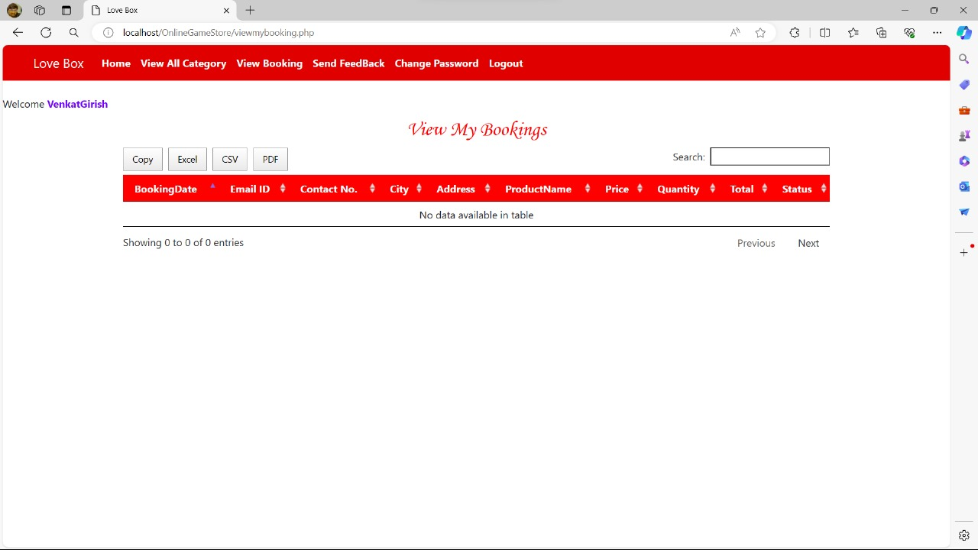

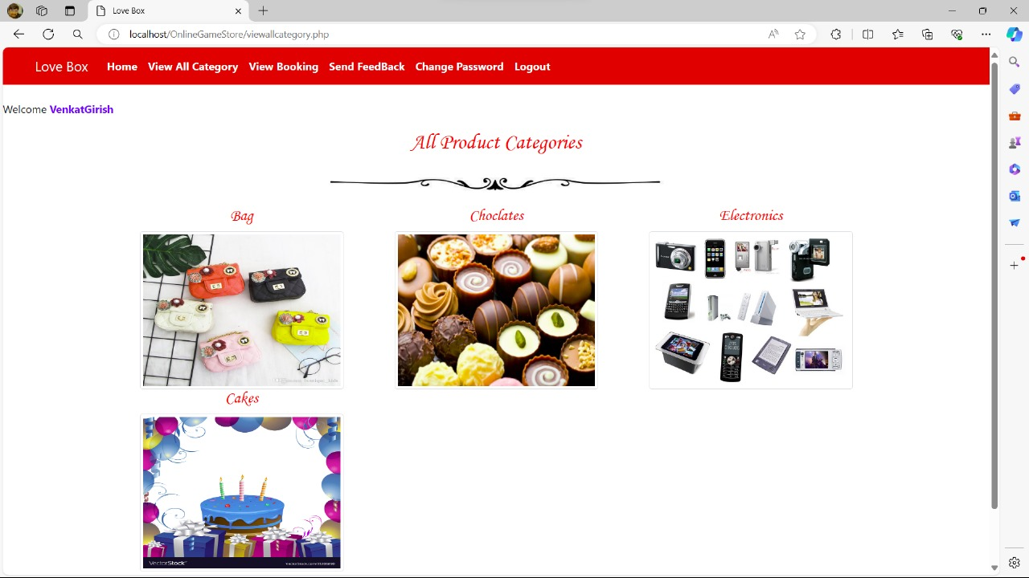

**Chapter 7**

## CONCLUSION

In conclusion, developing an online game store using web development offers numerous advantages, including accessibility, scalability, and customization options. By leveraging technologies such as HTML, CSS, JavaScript, and backend frameworks like Django or Node.js, businesses can create immersive and user-friendly platforms to showcase and sell games. Additionally, integrating features such as secure payment gateways, user reviews, and recommendation systems can enhance the overall user experience and drive sales. With continuous updates and improvements, an online game store built through web development can effectively cater to the growing demand for digital gaming content while staying competitive in the market.

**Chapter 8**

# 

# REFERENCES

[1] HTML and CSS: Design and Build Websites, by Jon Duckett[2] APA: Smith, J. (2023). Website development for beginners. ABC Publishing.[3] MLA: Smith, John. Website Development for Beginners. ABC Publishing, 2023.[4] T. J. Strader, J. J. Rozycki, T. H. Root and Y. H. J. Huang, "Machine learning stock market prediction studies: review and research directions", Journal of International Technology and Information Management, vol. 28, no. 4, pp. 63-83, 2020. [5] M. Obthong, N. Tantisantiwong, W. Jeamwatthanachai and G. Wills, A survey on machine learning for stock price prediction: Algorithms and techniques, 2020. [6] A. Subasi, F. Amir, K. Bagedo, A. Shams and A. Sarirete, "Stock market prediction using machine learning", Procedia Computer Science, vol. 194, pp. 173-179, 2021